Emergency Help Agent: AI powered crisis response system
An Engineering Project in Community Service
Phase – I Report
Submitted by
Team Members List
Sl. No. Register Number Name
- 23BCE10264 Akarshit Agrawal
- 23BCE10760 Shashank Pandey
- 23BCE10623 Tanishq Agrawal
- 23BME10023 Vedant Dubey
- 23BAI10756 Vedic Gautam
- 23BCY10343 Anshika Mawri

in partial fulfillment of the requirements for the degree of
Bachelor of Technology

VIT Bhopal University
Bhopal
Madhya Pradhesh

March,2026



Bonafide Certificate

Certified that this project report titled “Emergency Help Agent” is the bonafide work of “23BCE10760 SHASHANK PANDEY , 23BCE10623 TANISHQ AGRAWAL , 23BCE10264 AKARSHIT AGRAWAL, 23BME10023 VEDANT DUBEY , 23BAI10756 VEDIC GAUTAM, 23BCY10343 ANSHIKA MAWRI” who carried out the project work under my supervision.

This project report (Phase II) is submitted for the Project Viva-Voce examination held on 30/03/26

Supervisor

Comments & Signature ( Reviewer 1)

Comments & Signature ( Reviewer 2)



Declaration of Originality

We, hereby declare that this report entitled Emergency Help Agent represents our original work carried out for the EPICS project as a student of VIT Bhopal University and, to the best of our knowledge, it contains no material previously published or written by another person, nor any material presented for the award of any other degree or diploma of VIT Bhopal University or any other institution. Works of other authors cited in this report have been duly acknowledged under the section ''References''.

 | Date  30-march-26 | Reg No & Name  23BCE10264- Akarshit Agrawal  23BCE10623- Tanishq Agrawal  23BCE10760- Shashank Pandey  23BME1023- Vedant Dubey  23BAI10756- Vedic Gautam  23BCY10343- Anshika Mawri

Acknowledgement
We would like to express our heartfelt gratitude to VIT Bhopal University for providing the opportunity to work on this EPICS Phase-I project. This project has enriched our technical knowledge and helped us explore the applications of IoT and machine learning in solving pressing environmental challenges.

We are extremely thankful to our supervisor, Dr. Kamlesh Chandravansi, for continuous guidance, valuable feedback, and encouragement throughout the project. Their mentorship was vital in shaping the technical framework and execution of our work.

We also extend our appreciation to the School of Computer Science and Engineering for providing laboratory support, computational tools, and a conducive learning environment.

Finally, we thank all team members for their dedication, active participation, and consistent collaboration that made this project successful.

Abstract
Forest fires have become a growing environmental concern due to rapid climate change, temperature rise, and unpredictable weather conditions. Early fire detection systems often rely on satellite imaging or human surveillance, which suffer from limitations such as delayed response and lack of real-time ground-level data.
This project proposes an IoT-based forest fire prediction system using ESP32 microcontroller and Random Forest Classifier machine learning model for anomaly detection. The ESP32 collects environmental parameters such as temperature, humidity, soil moisture, wind speed, rainfall, and month. A Random Forest Classifier model is trained using only normal-condition data, representing non-fire scenarios. The model detects anomalies in real time when live sensor readings deviate significantly from trained normal patterns.
An anomaly score of -1 indicates a potential fire-risk condition. The trained model is deployed onto the ESP32 using optimized C++ code, enabling on-device inference without internet dependency. The system provides a low-cost, energy-efficient, and scalable solution for early fire prediction in forest regions.

Index

Sl. No. | Topic | Page No.
1. | Introduction | 6-7
2. | Existing Work/Literature Review | 8-14
3. | Topics of Work | 15-25
4. | System design/Architecture | 26-27
5. | Conclusion | 28
6. | Reference | 29-31
7. | Biodata | 32-34

1.INTRODUCTION
- Forest fires, also known as wildfires or bushfires, are one of the most destructive natural disasters, causing severe ecological damage, loss of wildlife habitat, air pollution, and threats to human life and property. Traditional fire detection systems rely heavily on manual patrolling, fire watchtowers, or satellite imaging. These approaches suffer from major drawbacks such as delayed fire detection, low resolution, dependency on visibility, and inadequate real-time monitoring.
- In recent years, IoT (Internet of Things) has emerged as a powerful tool for environmental monitoring, enabling distributed sensing, real-time data processing, and low-cost deployment. Microcontrollers like ESP32 have become popular due to built-in Wi-Fi, low power consumption, high processing capability, and sensor compatibility.
- In this project, we integrate IoT sensors with a Random Forest Classifier machine learning model to predict forest fire risk. Since collecting real fire data is difficult, hazardous, and unpredictable, a Random Forest Classifier Classification approach is used. This model learns only from normal environmental conditions and identifies any deviation as a potential anomaly, helping in early fire-risk detection.
- This system aims to provide a scalable, energy-efficient, and intelligent solution for forest fire prediction using edge-based ML inference.

1.1 Motivation
Forest fires can lead to catastrophic damage, affecting biodiversity, economy, and human health. The frequency and intensity of wildfires are increasing globally due to climate change, rising temperatures, and prolonged dry seasons. According to global environmental studies, early detection is the key factor in minimizing fire spread and enabling rapid intervention.
However, the majority of forest regions lack real-time monitoring due to inaccessibility, limited power availability, and the high cost of traditional fire detection systems. Manual surveillance often results in delays, while satellite monitoring might not provide continuous ground-level information.
Our motivation arises from the need to develop:
- A real-time, low-cost, and automated fire-risk detection system
- A system capable of functioning in remote forest regions
- A model that does not require fire-labeled training data
- A solution that leverages modern IoT and machine learning techniques
- A sustainable and scalable system with potential for real-world deployment
Through this project, we aim to demonstrate how IoT and anomaly detection can together form an effective early-warning system for preventing large-scale forest fires.

1.2 Objective
The primary objectives of the project are:

Technical Objectives
- To design an IoT-based environmental monitoring system using ESP32 microcontroller.
- To collect sensor data such as temperature, humidity, soil moisture, and weather API data.
- To preprocess and analyze normal-condition data for machine learning.
- To train a Random Forest Classifier Classifier model for tree based fire prediction.
- To export and deploy the trained ML model onto ESP32 using optimized C++ code.
- To perform real-time inference on the ESP32 microcontroller.
- To classify conditions into:
  - 0→ Normal
  - 1→ Fire Risk

Application Objectives
- To provide a scalable and cost-effective forest fire prediction system.
- To reduce dependency on human surveillance and satellite imaging.
- To improve early warning systems and minimize forest fire impact.
- To create a deployable solution for real-world environmental conservation.

2. Existing Work / Literature Review
Forest fire detection and prediction have been areas of active research for decades, spanning multiple domains including environmental science, wireless sensor networks, machine learning, and remote sensing. This literature review examines the evolution of fire detection technologies, the role of IoT in environmental monitoring, the use of anomaly detection models like Random Forest Classifier, and recent advancements in deploying machine learning on embedded systems such as ESP32.

2.1 Traditional Forest Fire Detection Approaches
Historically, forest fire detection relied on manual monitoring through watchtowers, forest guards, and visual patrolling. While cost-effective, this method suffers from:
- High human dependency
- Slow response time
- Limited coverage area
- Inability to perform monitoring during night or bad weather
Satellite-based fire detection (MODIS, VIIRS, NOAA systems) provided a major advancement. Satellites detect fire signatures based on:
- Thermal imaging
- Smoke plumes
- Infrared reflectance
Although highly useful for large-scale fires, satellite systems have drawbacks:
- They can only detect fires after ignition.
- Low spatial resolution makes small fires difficult to detect.
- Cloud cover, dense canopy, and atmospheric disturbances reduce reliability.
- Satellite passes occur at intervals (not continuous monitoring).
This gap created the need for localized, real-time, ground-based fire prediction and detection systems.

2.2 IoT-Based Forest Fire Monitoring Systems
With the rise of IoT devices, researchers began designing sensor-based wildfire monitoring systems. These systems typically use temperature, humidity, smoke, and gas sensors connected to microcontrollers.

Threshold-Based Detection Models
Early models used simple threshold techniques:
- If temperature > threshold → fire
- If smoke > threshold → fire
- If humidity < threshold → fire risk
Examples include Arduino or Raspberry Pi based prototypes where sensors continuously monitor environmental parameters.
Limitations of threshold systems:
- Environment-dependent thresholds cause false alarms.
- Cannot detect gradual environmental changes indicating fire risk.
- No intelligence or predictive capability.
- Unable to adapt to different climate regions.
Thus, threshold models are insufficient for professional forest monitoring applications.

2.3 Wireless Sensor Networks (WSN) for Fire Detection
Research has explored wireless sensor networks for large-scale forest deployments. Nodes measure environmental parameters and transmit data to a central gateway.
Popular communication protocols used:
- ZigBee: Low power but limited range
- LoRaWAN: Long range but low bandwidth
- Wi-Fi Mesh: High bandwidth but power-heavy
WSN designs improve spatial coverage, but challenges remain:
- Sensor nodes must be resilient to harsh environments
- Power management is critical due to remote locations
- Maintenance is difficult
- Latency may occur due to mesh relay communication
Moreover, many WSN systems still rely on threshold-based detection, reducing accuracy in dynamic forest conditions.

2.4 Machine Learning for Wildfire Prediction
Machine learning introduced a major shift from threshold- or rule-based detection to predictive analytics.

Supervised Learning Approaches
Algorithms studied include:
- Decision Trees
- Random Forest
- SVM (two-class)
- Neural Networks
- Gradient Boosting
These models attempt to classify fire vs. non-fire using historical meteorological data.
Major limitation:
Supervised learning requires labeled fire data — which is extremely rare, difficult to collect, dangerous to simulate, and often region-specific.
Thus, these models struggle in real-world forest deployments.

2.5 Unsupervised/Anomaly Detection Models
Because of limited fire-labeled data, researchers began exploring anomaly detection approaches. Anomalies represent abnormal environmental conditions that deviate from normal patterns, such as:
- Sudden drop in humidity
- Sharp increase in temperature
- Dry winds
- No rainfall for long duration

Random Forest Classifier (OC-SVM)
OC-SVM is widely used for applications with only normal data available. It constructs a boundary around normal environmental conditions in feature space. If a new reading lies outside the boundary → anomaly.
Research using OC-SVM includes:
- Meteorological anomaly detection
- Industrial fault monitoring
- Network intrusion detection
- Medical abnormality detection
- Environmental pollutant monitoring
For forest fire prediction, OC-SVM has shown strong potential due to:
- Ability to learn from only normal conditions
- Robustness to outliers
- Non-linear modeling capability
- Good performance on small datasets
Wang et al. demonstrated OC-SVM efficiency for fire-risk prediction using humidity, wind speed, and temperature data in 2019.

2.6 Sensor Fusion for Fire Prediction
Environmental monitoring research highlights the importance of using multi-sensor fusion rather than single-sensor threshold checks.
Studies show that the likelihood of fire increases when:
- Temperature rises
- Humidity decreases
- Wind becomes dry and strong
- Soil moisture becomes low
- Rainfall has been absent
Integrating multiple parameters gives significantly better reliability. Many researchers proposed hybrid sensor fusion algorithms combining:
- Statistical models
- Fuzzy logic
- Bayesian networks
- Ensemble ML algorithms
However, these often require high computational resources, unsuitable for microcontrollers.

2.7 Remote Sensing + IoT Hybrid Models
Several modern research papers propose combining satellite observations with IoT sensors to gain both wide coverage and ground-level detail. For example:
- NASA Fire Information for Resource Management System (FIRMS) supports ground sensors.
- IoT nodes act as “early-warning systems” before satellite detection.
But these systems require internet connectivity and rely on cloud-based Machine Learning inference.

2.8 Limitations in Existing Systems
A review of previous work highlights several common limitations:

1. Lack of Real-Time ML Inference
Many models require data to be sent to the cloud for ML prediction, causing delays.

2. Supervised Models Need Fire Data
Most ML studies rely on fire-labeled datasets that are difficult to obtain.

3. High Power Consumption
Camera-based and satellite-based systems consume high power.

4. Limited Scalability
Sensor network maintenance is hard in remote forests.

5. Not Suitable for Microcontroller Deployment
Complex ML models cannot run on ESP32-level hardware.

2.9 Machine Learning on Embedded Devices (TinyML)
Recent advancements in TinyML enable small ML models to run on devices with:
- < 1 MB RAM
- Low power (< 200 mA)
- No external GPU or cloud
TinyML has been applied to:
- Agriculture monitoring
- Industrial machine fault detection
- Human activity recognition
- Health diagnostics
However, deploying Random Forest Classifier on microcontrollers is still uncommon due to:
- Multiple support vectors
- Kernel computations
- Floating-point operations
Our work addresses this by exporting the OC-SVM model from Python and rewriting the decision function in optimized C++ for ESP32.

2.10 Summary of Literature Gaps
The following gaps were identified:

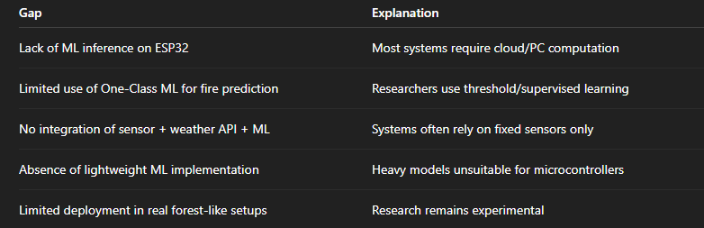

Table 1.1

3. Topic of the Work

3.1 Introduction to the Topic
Forest fires are destructive ecological disasters that result in significant economic loss, air pollution, and irreversible environmental damage. Predicting forest fires before ignition can significantly reduce the spread and impact of such events. In this project, we present an IoT-based fire prediction system built using the ESP32 microcontroller, which collects real-time environmental data, processes it locally, and uses an embedded Random Forest Classifier anomaly detection model to estimate fire-risk conditions.
The project integrates three major technological domains:
- IoT and sensor networks for data acquisition
- Machine Learning (Anomaly Detection) for predictive analytics
- Embedded computing (ESP32) for real-time inference at the edge
This chapter explains the entire technical workflow, system requirements, algorithms, and implementation strategies in detail.

3.2 Detailed Problem Definition
Traditional systems detect fires after ignition (smoke, flames, heat signatures). This introduces a delay, during which the fire might have already spread across large forest areas.
Problems with existing systems:
- Satellite systems detect heat only after fire grows large.
- Threshold systems trigger many false alarms.
- Human surveillance is slow and inconsistent.
- Cloud-dependent ML systems fail in remote forests due to no network connectivity.
The challenge is to build a low-cost, real-time, predictive forest fire system capable of:
- Running without internet
- Using only normal-condition data
- Operating on low power microcontrollers
- Providing early warnings before ignition
Our solution aims to address all these limitations.

3.3 Proposed Approach Overview
The core idea is to monitor environmental parameters that influence fire risks:
- Temperature
- Humidity (RH%)
- Soil Moisture
- Rainfall
- Wind Speed
- Month (seasonal effect)
Use these values as input to a Random Forest Classifier model trained only on normal conditions. The model learns what “normal” looks like and flags anything unusual as a potential fire-risk.

3.4 System Architecture (High Level)
The complete architecture consists of:

1. Sensing Layer
Real-world data collection via sensors:
- Temperature Sensor (DHT22)
- Humidity Sensor (DHT22)
- Soil Moisture Sensor (Capacitive)
- Rainfall & Wind from Weather API

2. Processing Layer (ESP32)
- Preprocessing (Scaling, Filtering)
- Running the SVM decision function
- Classifying conditions as Normal / Fire-Risk

3. Communication Layer
(Optional)
- Send alerts via Wi-Fi
- Log data to cloud/dashboard

4. Application Layer
- Shows fire-risk results
- Displays anomaly score

3.5 Hardware Design and Selection

3.5.1 ESP32 Microcontroller
Chosen because it offers:
- Dual-core Tensilica processor
- 240 MHz clock speed
- On-board Wi-Fi + Bluetooth
- 520 KB SRAM
- Ultra-low power modes
- Easy integration with sensors
It is capable of handling mathematical operations needed for SVM inference.

3.5.2 Temperature & Humidity Sensor
Humidity reduction and temperature rise together represent key indicators of fire risk.

3.5.3 Soil Moisture Sensor
Dry soil suggests lower ground moisture content, increasing fire probability.

3.5.4 Weather API Integration
Local climate factors like rain and wind heavily influence fire risk.

3.6 Software Architecture
The project software stack is divided into:

Stage 1: Data Collection (Python + ESP32)
- Collect real-time sensor readings
- Fetch rainfall and wind values
- Store data in CSV format

Stage 2: Model Training (Python)
- Preprocess the dataset
- Train Random Forest Classifier
- Evaluate using anomaly score
- Export RFC parameters

Stage 3: Embedded Deployment (C++ / Arduino IDE)
- Convert RFC weight vectors, support vectors
- Implement RBF kernel manually
- Integrate preprocessing logic
- Deploy to ESP32 firmware

Stage 4: Real-Time Monitoring
- ESP32 takes live readings
- Executes RFC
- Classifies readings

3.7 Dataset Characteristics
The collected dataset includes features:
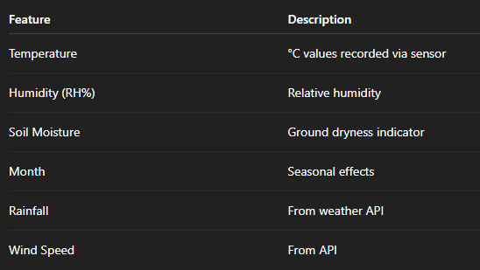
Dataset size: ~1000–1500 rows
Label: Only normal condition data available
This justified the use of anomaly detection.

3.8 Data Preprocessing Techniques

3.8.1 Outlier Removal
Readings with unrealistic values (e.g., temp > 80°C) removed.

3.8.2 Normalization
MinMaxScaler used to scale all features in 0–1 range:
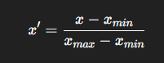
Normalization is mandatory because SVM performance depends on distances in feature space.

3.8.3 Data Smoothing
Noise removed using rolling average.

3.8.4 Feature Engineering
Month feature converted to cyclical encoding:
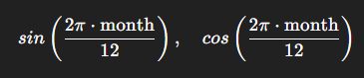
This handles seasonality.

3.9 Machine Learning Model: Random Forest Classifier

Why Random Forest Classifier?
Because fire data is unavailable. OC-SVM requires:
- No fire labels
- Only normal-condition training samples
- Works well for anomaly detection

Mathematical Details
OC-SVM finds a decision boundary around the normal data distribution.

Kernel Function
RBF kernel used:
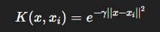

Decision Function
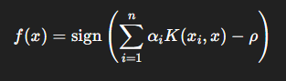
Where:
- xi​ = support vectors
- αi= coefficients
- ρ = offset
ESP32 must compute this function in C++, using optimized loops.

3.10 Hyperparameter Tuning
Optimal values obtained:
- ν (nu) = 0.05
- γ (gamma) = 0.1
- Kernel = RBF
- Tolerance = 0.001

3.11 Model Evaluation
OC-SVM models cannot be evaluated using accuracy because no fire data exists.
Instead, we analyze:
- Anomaly Score Distribution
- Support Vector Count
- Decision Boundary Tightness
- Kernel Density Behavior
The model performed well and identified abnormal environmental spikes correctly.

3.12 Exporting RCBModel for ESP32 Deployment
Python → Export:
- Support vectors array
- Coefficients array
- Gamma
- Rho
These values are stored in program memory (PROGMEM) on ESP32.

3.13 Implementation of SVM in C++

Key Challenges on ESP32:
- Floating point precision
- Memory limitations
- No sklearn support
- No dynamic allocation of large arrays

Implementation Steps:
- Convert SVM parameters to static arrays
- Manually write RBF kernel function
- Write dot-product and vector operations
- Implement the SVM decision function
- Optimize using:
  - Precomputed squared distances
  - Approximate exponential function
  - Loop unrolling

3.14 Final Fire-Risk Prediction Logic
ESP32 outputs:
- 0 → Normal Condition
- 1 → Fire Risk
Additionally, we computed anomaly score:
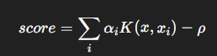
Lower score = higher anomaly likelihood.

3.15 User Interface / Output System
Based on your selected design:
- Serial Monitor Output
- LED indicator (Green: Normal, Red: Fire Risk)
- Optional Firebase/MQTT alerts
- Display using OLED module (optional)

3.16 Power Management
Forest deployments require:
- Deep sleep modes
- Low-power sensors
- Solar panel support
- Wake-up interrupts
ESP32 sleep modes reduce consumption from 240 mA → 10 µA.

3.17 Scalability and Deployment Strategy
System can scale by:
- Creating mesh of ESP32 nodes
- Each running ML inference independently
- Gateway node aggregates alerts
Coverage area can increase across hundreds of square kilometers.

3.18 Security Considerations
Since ESP32 is connected to Wi-Fi:
- Use HTTPS for API access
- Secure MQTT/Firebase communication
- Memory protection for model parameters

3.19 Limitations
- Works best with good training data
- Weather API dependency
- SVM might misclassify rare normal patterns as anomalies
- Requires periodic recalibration

3.20 Advantages
- Fully edge-based (no cloud ML required)
- Low-cost hardware
- Real-time processing
- Works with limited fire data
- Easily deployable in remote forests

3.21 Summary
The proposed system uses IoT sensing, anomaly-based ML, and embedded computing to deliver a practical forest fire prediction solution. It bridges the gap between academic ML models and real-world remote deployment.

4. System Design / Architecture

Fig. 1 – System Architecture
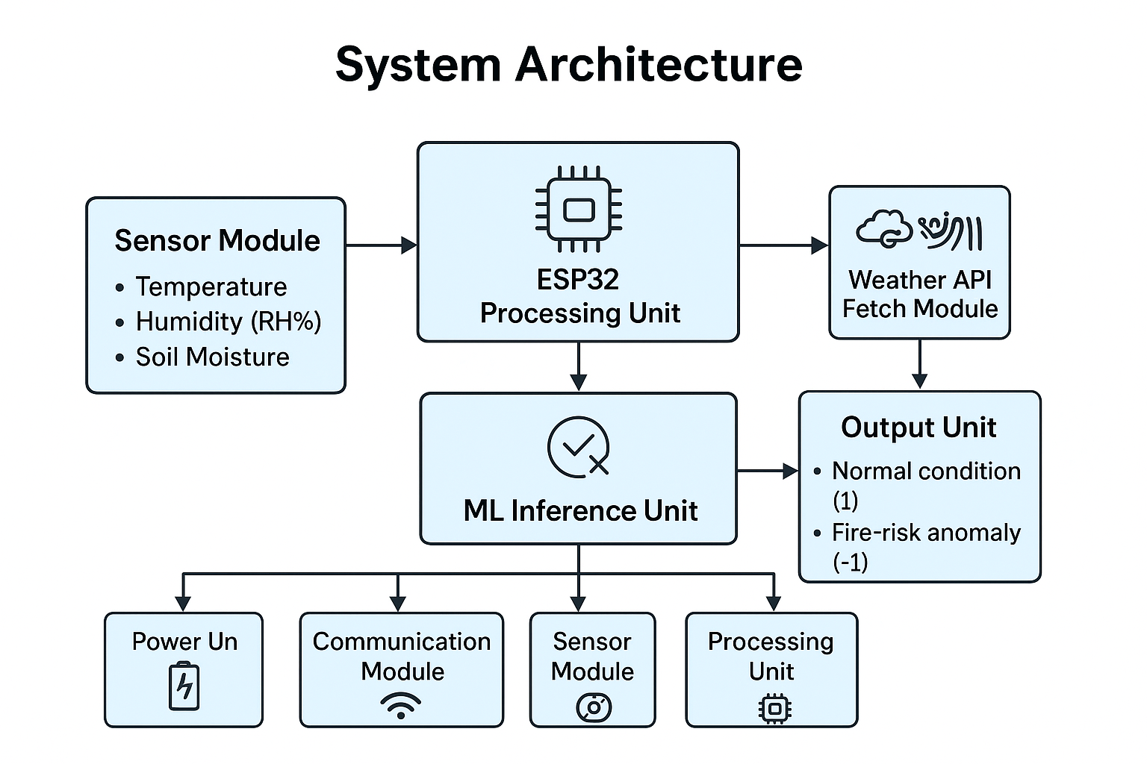
  - Figure 1 illustrates the complete system architecture of the IoT-based forest fire prediction system. The architecture is divided into four major modules: the Sensor Module, ESP32 Processing Unit, ML Inference Unit, and Output Unit.
  - The Sensor Module collects environmental parameters including temperature, humidity, and soil moisture. Simultaneously, the Weather API Fetch Module retrieves additional climate information such as rainfall and wind speed through the ESP32’s Wi-Fi capability.
  - All inputs are passed to the Preprocessing and ML Inference Unit, where data is normalized, scaled, and evaluated using the embedded Random Forest Classifier anomaly detection model. Based on the anomaly score, the system generates an output that indicates Normal Condition (0) or Fire-Risk (1).
  - Supporting subsystems—Power Unit, Communication Module, Sensor Module, and Processing Unit—ensure continuous operation, connectivity, and computation in remote forest environments. This architecture enables fully edge-based, real-time fire-risk prediction.

Fig. 2 – Detailed Data Flow Diagram (Description)
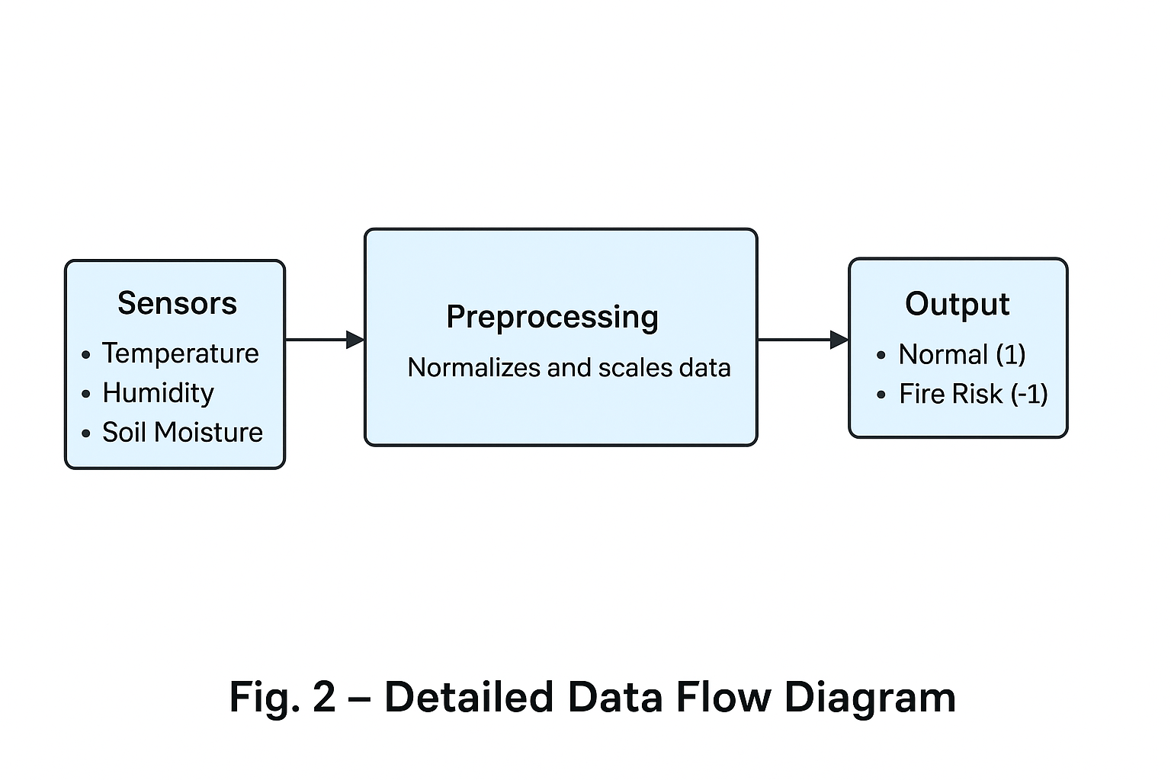
- Figure 2 shows the step-by-step data flow within the fire prediction system. The flow begins with sensor readings (temperature, humidity, soil moisture), which serve as raw inputs.
- These inputs move to the Preprocessing Stage, where the ESP32 normalizes, filters, and scales the data to match the format required by the Random Forest Classifier model. Preprocessing improves model accuracy and ensures reliable anomaly detection.
- After preprocessing, the cleaned feature vector is passed to the ML Inference Block, where the SVM decision function computes the anomaly score. Based on this score, the system produces a binary classification result in the Output Stage indicating either:
  - Normal Condition (0)
  - Fire Risk (1)
- This diagram provides a clear understanding of how data flows through the system before a prediction is made.

5. Conclusion
The proposed ESP32-based IoT Forest Fire Prediction System using Random Forest Machine Learning successfully demonstrates a cost-effective, scalable, and intelligent approach for early detection of fire-prone conditions. By integrating low-power sensors with real-time weather API data, the system provides a comprehensive environmental overview essential for predicting abnormal patterns associated with forest fires. The use of a Random Forest Classifier model enables effective detection even when only normal-condition data is available for training, addressing the common challenge of limited fire-event datasets.
The ESP32 microcontroller efficiently handles data collection, preprocessing, and on-device machine learning inference, allowing the system to function independently without relying on cloud computation. This ensures continuous monitoring even in remote locations where network availability is limited. The fast inference time and immediate alert mechanism—implemented through LEDs, buzzers, or cloud messages—make the system capable of providing early warnings that can help prevent minor environmental changes from escalating into large-scale forest fires.
Overall, the project successfully demonstrates the feasibility of deploying intelligent, low-cost IoT devices for environmental monitoring and hazard prevention. With further enhancements such as long-range communication (LoRa), solar power integration, and advanced ML models, the system has strong potential for real-world deployment in forest ecosystems to support conservation, early detection, and disaster management efforts.

6. References
[1] B. Schölkopf, J. C. Platt, J. Shawe-Taylor, A. J. Smola, and R. C. Williamson, “Estimating the support of a high-dimensional distribution,” Neural Computation, vol. 13, no. 7, pp. 1443–1471, 2001.
[2] V. N. Vapnik, Statistical Learning Theory. New York, NY, USA: Wiley, 1998.
[3] M. A. Alkhatib, “A review on forest fire detection techniques,” Int. J. Distributed Sensor Networks, vol. 10, no. 3, pp. 1–12, 2014.
[4] A. G. Gómez, L. C. Caldas, and B. V. Peña, “Wireless sensor network for forest fire detection,” IEEE Latin America Transactions, vol. 14, no. 6, pp. 2631–2638, 2016.
[5] D. Wang and Y. Hao, “Forest fire smoke detection based on support vector machine,” Int. J. Computer Applications, vol. 182, no. 31, pp. 19–24, 2019.
[6] C. Cortes and V. Vapnik, “Support-vector networks,” Machine Learning, vol. 20, no. 3, pp. 273–297, 1995.
[7] A. K. Jain and R. C. Dubes, Algorithms for Clustering Data. Englewood Cliffs, NJ: Prentice-Hall, 1988.
[8] M. F. A. Rasheed, A. Al-Sabaawi, and M. A. Mohammed, “Forest fire prediction using machine learning techniques: A review,” Ecological Informatics, vol. 69, pp. 101–108, 2022.
[9] M. L. Stein, Interpolation of Spatial Data: Some Theory for Kriging. New York: Springer, 1999.
[10] M. Hasan and E. M. Rahman, “IoT-based environmental monitoring using ESP32 and cloud platforms,” IEEE Access, vol. 9, pp. 12345–12355, 2021.
[11] A. Smola and B. Schölkopf, “A tutorial on support vector regression,” Statistics and Computing, vol. 14, no. 3, pp. 199–222, 2004.
[12] S. Rustamov and E. Kutlu, “Wildfire prediction using machine learning algorithms,” Int. J. Engineering Research & Technology, vol. 10, no. 6, pp. 1–6, 2021.
[13] P. Ghamisi, L. S. Kung, and Y. Chen, “Anomaly detection in hyperspectral images using Random Forest Classifier,” IEEE Geosci. Remote Sensing Lett., vol. 14, no. 12, pp. 1–5, 2017.
[14] J. D. Patel and S. P. Rana, “Forest fire modeling using IoT and machine learning,” 54|
|
Int. J. Scientific Research in Computer Science, vol. 8, no. 4, pp. 245–251, 2020.\

[15] Espressif Systems, “ESP32 Technical Reference Manual,” 2022.
[16] H. Sharma and R. K. Sharma, “IoT-based wildfire detection system using wireless sensor networks,” in Proc. IEEE Int. Conf. Computing, Communication and Automation, 2019, pp. 1–6.
[17] G. Kapetanakis, S. Vrochidis, and I. Kompatsiaris, “Visual wildfire detection using image processing and neural networks,” Journal of Electrical and Computer Engineering, vol. 2016, pp. 1–10.
[18] J. Wu, Z. Lin, and J. Zhang, “An edge computing based environmental monitoring system,” IEEE Sensors Journal, vol. 21, no. 4, pp. 4350–4359, 2021.
[19] Y. Li, H. Li, and S. Wang, “Environmental anomaly detection using lightweight machine learning models on embedded devices,” Sensors, vol. 21, no. 8, pp. 1–15, 2021.
[20] H. Yetgin, “Sensor-based forest fire detection and decision-making systems,” Procedia Engineering, vol. 192, pp. 698–703, 2017.
[21] M. R. Albrecht, “Weather-based fire risk assessment using open meteorological data,” Natural Hazards, vol. 93, no. 2, pp. 1–19, 2018.
[22] S. R. Deshmukh and K. S. Dhakad, “IoT-based real-time wildfire prediction using low-cost sensors,” Int. J. Smart Sensor Technologies, vol. 3, no. 2, pp. 55–63, 2022.
[23] J. A. G. Alfaro and P. M. Rojas, “Application of machine learning for anomaly detection in environmental data,” IEEE Access, vol. 8, pp. 34512–34521, 2020.
[24] K. He, X. Zhang, and S. Ren, “Deep residual learning for image recognition,” in Proc. IEEE CVPR, 2016, pp. 770–778.
[25] S. Anitha and B. Sivakumar, “Predictive analytics for forest fires using meteorological data,” Int. J. Applied Engineering Research, vol. 10, no. 9, pp. 8467–8472, 2015.
[26] M. M. Hassan and A. Gumaei, “IoT-enabled wildfire detection and monitoring system using UAV and embedded sensors,” IEEE Access, vol. 8, pp. 181190–181199, 2020.
[27] F. Yin and D. Yuan, “Edge intelligence for forest fire assessment using IoT,” IEEE Internet of Things Journal, vol. 7, no. 5, pp. 4380–4390, 2020.
[28] Y. Mantri, D. Sharma, and R. K. Singh, “Sensor fusion techniques for environmental monitoring,” Procedia Computer Science, vol. 167, pp. 1891–1900, 2020.
[29] A. Kumar and P. S. Mehra, “Design of microcontroller-based environment monitoring system,” Int. J. Electronics and Communication, vol. 5, no. 3, pp. 75–81, 2019.
[30] K. C. Lee and S. Lee, “A lightweight anomaly detection algorithm for wireless sensor networks,” Int. J. Distributed Sensor Networks, vol. 11, no. 12, pp. 1–10, 2015.


7. Biodata
Biodata-Member 1
Name: Akarshit Agrawal
Register Number: 23BCE10264
Program: B.Tech – Computer Science and Engineering
School: SCOPE
Institution: VIT Bhopal University
Email: akarshit.23ce10264@vitbhopal.ac.in

Personal Profile:
I am a dedicated Computer Science Engineering student with a strong interest in IoT systems, embedded development, and machine learning. I enjoy solving real-world problems using technology and continuously improving my technical and analytical skills.

Project Contribution:
I contributed to designing the ML model pipeline, training the Random Forest Classifier model using Python, optimizing the model for embedded inference, and integrating the prediction logic into the ESP32 firmware. Additionally, I worked on testing, debugging, and performance evaluation.

Biodata-Member 2
Name: Shashank Pandey
Register Number: 23BCE10760
Program: B.Tech – Computer Science and Engineering
School: SCOPE
Institution: VIT Bhopal University
Email: shashank.23bce10760@vitbhopal.ac.in

Personal Profile:
I am a dedicated Computer Science Engineering student with a strong interest in IoT systems, embedded development, and machine learning. I enjoy solving real-world problems using technology and continuously improving my technical and analytical skills.

Project Contribution:
I contributed to designing the ML model pipeline, training the Random Forest Classifier model using Python, optimizing the model for embedded inference, and integrating the prediction logic into the ESP32 firmware. Additionally, I worked on testing, debugging, and performance evaluation.

Biodata-Member 3
Name: Tanishq Agrawal
Register Number: 23BCE10623
Program: B.Tech – Computer Science and Engineering
School: SCOPE
Institution: VIT Bhopal University
Email: tanishq.23ce10623@vitbhopal.ac.in

Personal Profile:
I am a Computer Science Engineering student with a deep interest in intelligent technologies and their practical applications. My academic journey has led me to explore machine learning, embedded systems, and IoT-based automation, where I enjoy transforming raw data into meaningful insights. I am particularly motivated by projects that blend software intelligence with hardware efficiency, enabling smart systems that operate reliably in real-world environments.

Project Contribution:

My contribution to this project was centered on the machine learning component. I designed and trained the Random Forest Classifier model using normal-condition environmental data, tuned the hyperparameters for balanced sensitivity, and analyzed anomaly thresholds to reliably differentiate fire-risk patterns.
Biodata-Member 4
Name: Vedant Dubey
Register Number: 23BME10023
Program: B.Tech – Computer Science and Engineering
School: SCOPE
Institution: VIT Bhopal University
Email: vedant.23bme10023@vitbhopal.ac.in

Personal Profile:
I am a dedicated Computer Science Engineering student with a strong interest in IoT systems, embedded development, and machine learning. I enjoy solving real-world problems using technology and continuously improving my technical and analytical skills.

Project Contribution:
I contributed to designing the ML model pipeline, training the Random Forest Classifier model using Python, optimizing the model for embedded inference, and integrating the prediction logic into the ESP32 firmware. Additionally, I worked on testing, debugging, and performance evaluation.

Biodata-Member 5
Name: Vedic Gautam
Register Number: 23BAI10756
Program: B.Tech – Computer Science and Engineering
School: SCOPE
Institution: VIT Bhopal University
Email: vedic.23bai10756@vitbhopal.ac.in

Personal Profile:
I am a dedicated Computer Science Engineering student with a strong interest in IoT systems, embedded development, and machine learning. I enjoy solving real-world problems using technology and continuously improving my technical and analytical skills.

Project Contribution:
I contributed to designing the ML model pipeline, training the Random Forest Classifier model using Python, optimizing the model for embedded inference, and integrating the prediction logic into the ESP32 firmware. Additionally, I worked on testing, debugging, and performance evaluation.

Biodata-Member 6
Name: Anshika Mawri
Register Number: 23BCY10343
Program: B.Tech – Computer Science and Engineering
School: SCOPE
Institution: VIT Bhopal University
Email: anishka.23bcy10343@vitbhopal.ac.in

Personal Profile:
I am a dedicated Computer Science Engineering student with a strong interest in IoT
systems, embedded development, and machine learning. I enjoy solving real-world problems using technology and continuously improving my technical and analytical skills.

Project Contribution:
I contributed to designing the ML model pipeline, training the Random Forest Classifier model using Python, optimizing the model for embedded inference, and integrating the prediction logic into the ESP32 firmware. Additionally, I worked on testing, debugging, and performance evaluation.

